

SIMATS ENGINEERING

Saveetha Institute of Medical and Technical Sciences Chennai- 602105
Student Name: V.Tejaswini Reg. No.:192424360
Course Code: DSA0613 Slot:A
Course Name: Data Handling &Data visualization for Data Analytics
Course Faculty: Dr.Kumargurubaran &Dr.Senthilvadivu

Project Title: AGRI VISION – CROP PRODUCTION INTELLIGENCE PLATFORM
Module Photographs:
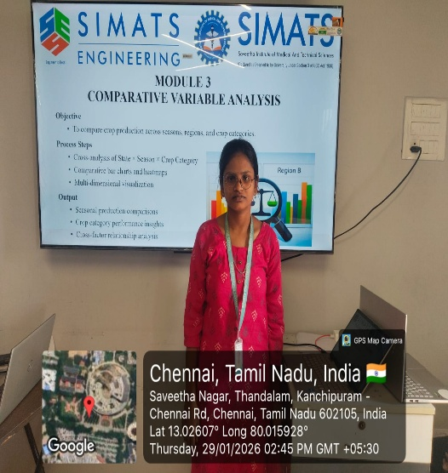 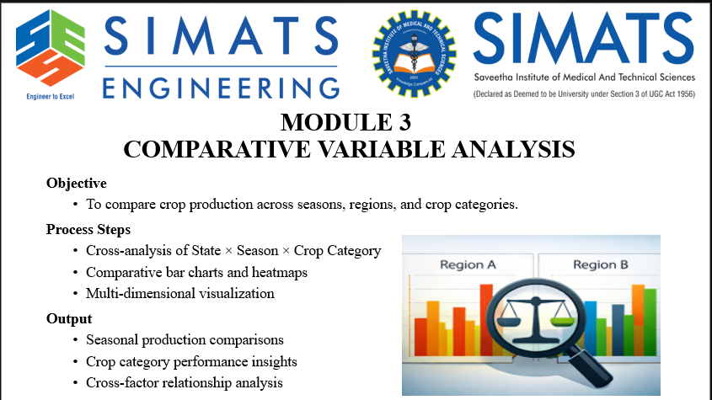r 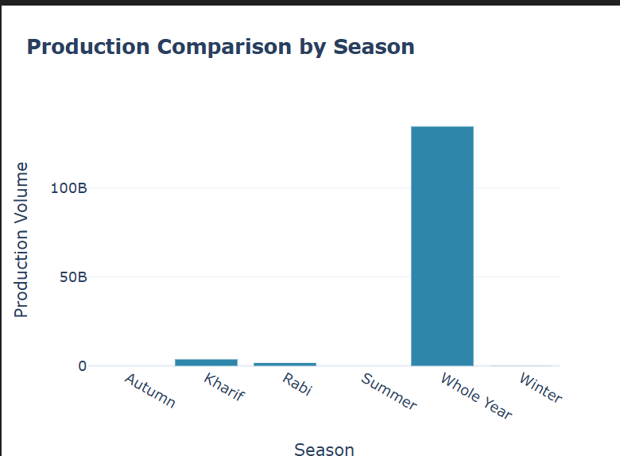
Project Description:
AGRI VISION – Crop Production Intelligence Platform is a smart technology-based system designed to support agricultural activities. It helps farmers and agricultural users make better decisions related to crop production. The platform collects important data such as soil type, weather conditions, rainfall, and temperature. This data is analyzed to provide useful insights for farming. AGRI VISION suggests suitable crops based on current farm conditions. It also helps in planning the right time for planting and harvesting. The system aims to reduce crop losses and farming risks. AGRI VISION is easy to use and understandable for all users. Overall, the platform promotes efficient, smart, and sustainable farming practices. The platform can also help farmers understand crop trends and future possibilities. It supports better use of water, fertilizers, and other farm resources. AGRI VISION helps farmers adapt to changing climate conditions. platform promotes efficient, smart, and sustainable farming practice.

Student Signature Guide Signature

